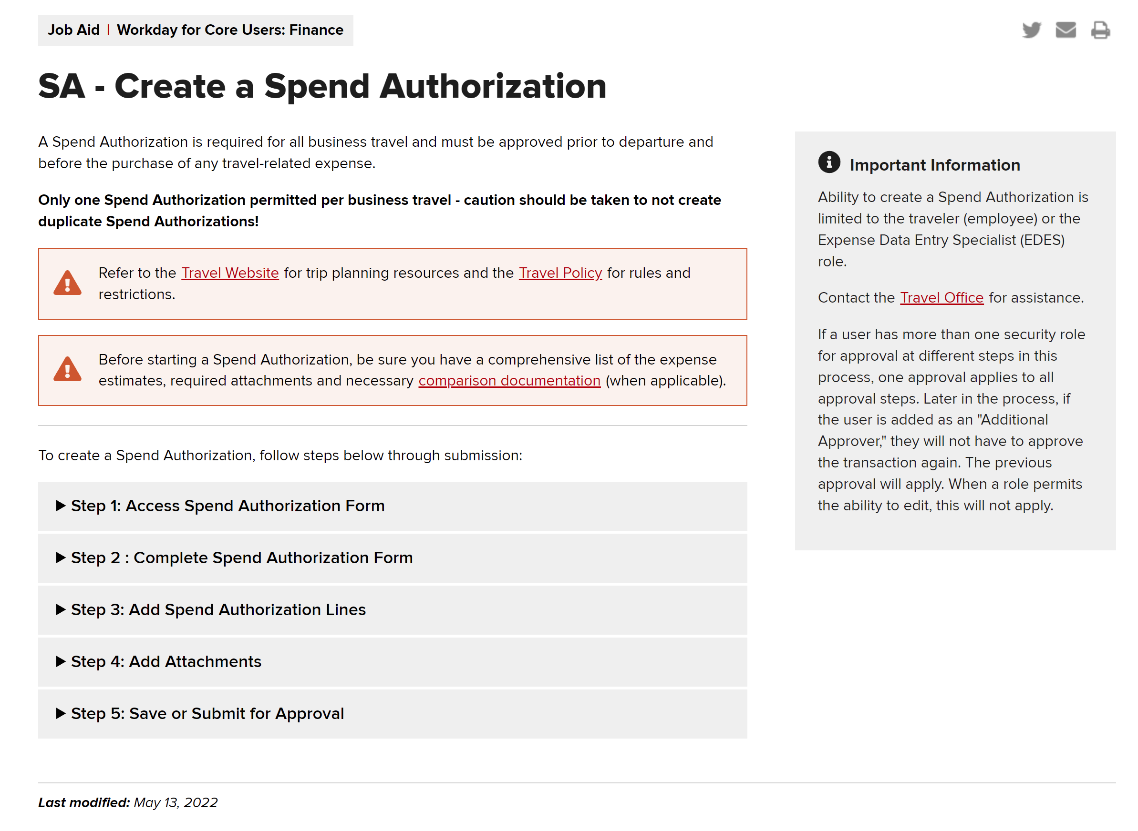
*Create a Spend Authorization Link
https://admin.resources.osu.edu/workday/workday-for-core-users-finance/sa-create-a-spend-authorization
*Travel Website Link
https://busfin.osu.edu/buy-schedule-travel/travel
*Comparison Documentation Link
https://busfin.osu.edu/sites/default/files/comparison_form_june_2021.pdf
*Travel Office Email
travel@osu.edu
*Airfare
All employee business travel airfare must be procured through the university's contracted travel agency Corporate Travel Planners (CTP) with an approved Spend Authorization (SA) number. You can email theohiostate@ctptravelservices.com or call 1-855-784-9282 with your Spend Authorization number, Employee ID number (found under your name in Workday), and it is VERY important to let the CTP rep via email or phone know if this travel/ SA# will be going on a grant or not. You can email CTP the flights you prefer, and they are really good about getting those
To access their website, go to https://busfin.osu.edu/buy-schedule-travel/travel and click Book Travel Online. Use the Trip Search tool to find your preferred flight itinerary, view rates, and gather flight cost comparisons when applicable.
OSU Travel Policy https://busfin.osu.edu/sites/default/files/policy-edit-travel-20220516.pdf
*Ground Transportation
- Rental Car: Discounted rates and required insurances are included when using the university’s contracted suppliers for rental cars. **Please Note** This requires a pre-approval by constructing a detailed email with your SA#, travel dates & why it is vital for you to have a rental car. This detailed pre-approval email gets sent to the Byrd Director, Ian Howat (howat.4) & ERIK Manager, Karen Liming (liming.1).
  - See Rental Car Discounts for rates, reservations and other details for rentals with Enterprise, National or Hertz.
- Personal Vehicle Mileage: Personal vehicles can be used as a primary mode of transportation if the cost does not exceed the least expensive airfare or rental car. Reimbursement for use of a personal vehicle is based on the IRS mileage rate and is inclusive of the cost for gasoline, wear and tear of the vehicle and personal auto insurance. For the current mileage rate, see U.S. General Services Administration (link is external).
*Lodging & Per Diem
Under your Spend Authorization, there is a link under the expense line for lodging/ per diem for domestic and international per diem rates. When you put the city in for the per diem, it will automatically populate the daily rate. For example: if you are staying in a hotel that offers a complementary breakfast, then you would remove that amount from the daily rate.
Refer to the https://busfin.osu.edu/sites/default/files/policy-edit-travel-20220516.pdf for more information.

Travel Reimbursement
*All reimbursement documentation must be submitted within 60 days. The traveler is no longer eligible for reimbursement beyond the 60-day limit.
1. Submit the Travel Reimbursement Worksheet found at travel_reimbursement_form.pdf (no signature required). An electronic or hard copy is accepted.
2. Submit original itemized receipts showing proof of payment. Electronic receipts are accepted. Receipts are not required for meals (per diem) or mileage.

