COLUMN | UNIT
time_stamp | Zulu Time (Z) - 5 hours ahead of Eastern Standard Time (EST)
humidity | %
temperature | °F
pressure (Raw Pressure; Not Adjusted for SLP) | Millibars (mb)
Pm2.5_atm | µg/m³ – Concentration (in micrograms) of fine particulate matter with a diameter of less than 2.5 micrometers (PM_{2.5}) per meter cubed.

PM_{2.5} SCALE GUIDE:
Generally, over a 24-hour period:
≤12 µg/m³ – Healthy; little to no risk
≥35 µg/m³ – Unhealthy; issue for people with existing breathing problems (e.g., asthma)
>55 µg/m³ – Unhealthy for people without existing breathing problems; premature mortality if prolonged exposure
https://www.indoorairhygiene.org/pm2-5-explained/
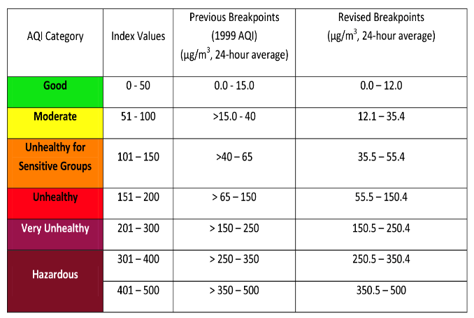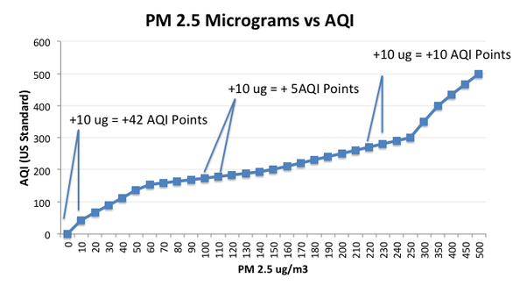

INSTRUCTIONS FOR LOOKING UP PM_{2.5} DATA & SENSOR LOCATION ON PURPLEAIR LIVEMAP:
1. Go to https://map.purpleair.com/1/mAQI/a30/p31536000/cC0#10.93/39.9867/-82.9827.
2. Click on the magnifying glass in the top right corner of the screen.
3. Type one of the three station tags. The tags are the file name minus the extension (e.g., MORPC_30)

